**OFFICIAL COORDINATION REQUEST FOR NON- ROUTINE OPERATIONS AND MAINTENANCE**

**COORDINATION TITLE- 17BON59 WA Shore LPS Flow Sensors Retrofit**

**COORDINATION DATE- 26 July 2017**

**PROJECT- BONNEVILLE Lock and Dam**

**RESPONSE DATE- 10 August 2017**

**Description of the problem-** Bonneville Powerhouse 2 Washington shore Lamprey Passage Structure (LPS) flow sensors need to be replaced. The flow sensors currently in place are not reliable and will be replaced with a new system to ensure proper notification to dam operators that a pump has failed. Currently there are two pumps that operate concurrently to provide design flow to the LPS and associated rest boxes. If one pump fails the system will provide enough water to maintain lamprey and allow enough time for replacement of the failed pump.

**Type of outage required-** The work is scheduled to occur during a portion of the work window coordinated under MOC 17BON20. The work will require the LPS pumps to be shut off periodically over the course of 1 to 2 days (14 AUG to 15 AUG) and therefore will be out of service for up to 2 days. The work will occur within 50 feet of the fish ladder adjacent to the AWS on the outside of the wall for up to 5 days (Figure 1). The remaining 3 days will be used to pull wire for the new flow sensors, test new sensors, and demobilize. 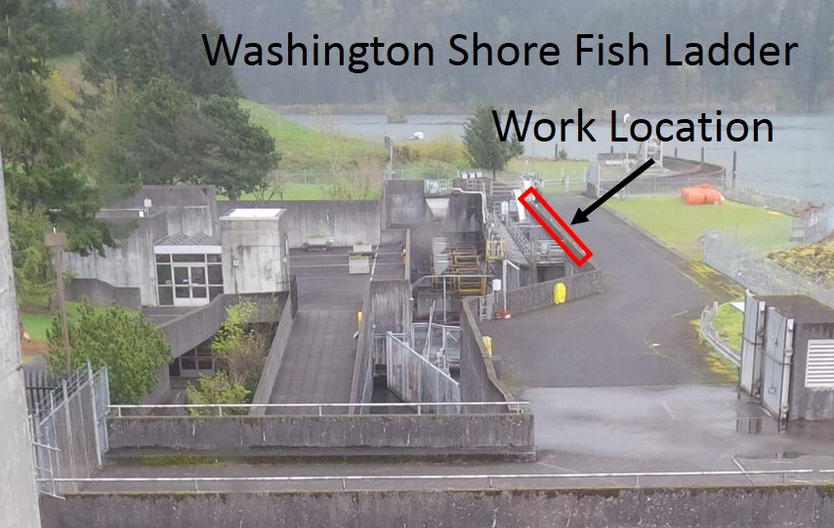

**Figure 1.** Bonneville Washington Shore Fish ladder exit. The location where new conduit will be installed to replace existing flow sensors.

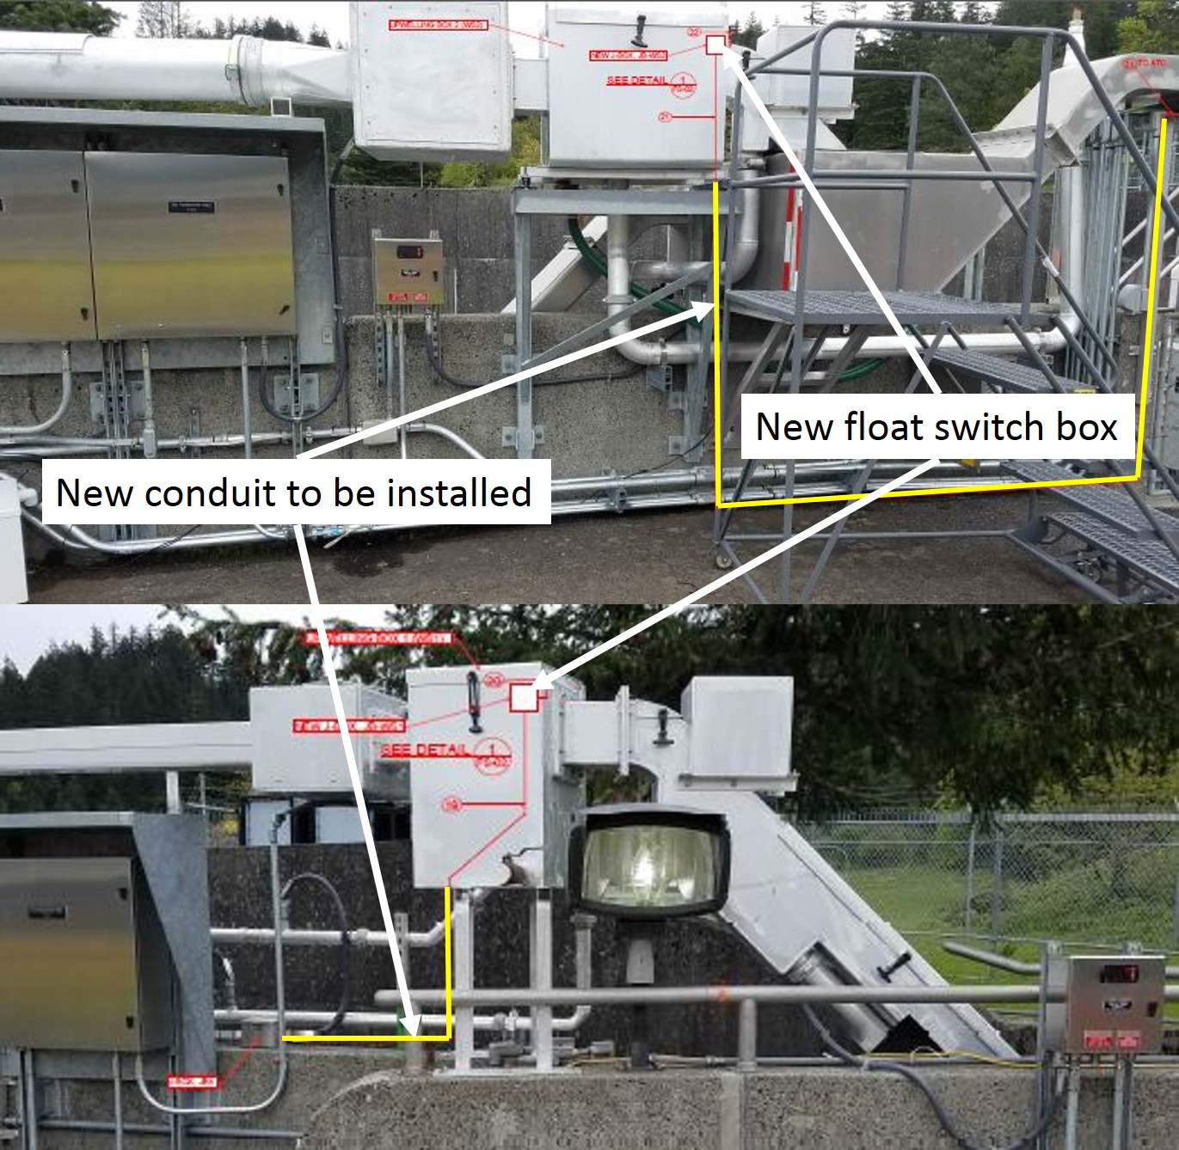

**Figure 2.** The Washington Shore LPS upwelling boxes to be retrofitted with new flow sensors (white boxes) and associated conduit (yellow lines) to be installed.

**Impact on facility operation-** The WA shore LPS will be out of service for ~2 days.

**Dates of impacts/repairs**- August 14-18, 2017.

**Length of time for repairs-** 5 days total.

**Expected impacts on fish passage-**

Bull Trout-

Of the five distinct population segments (DPS) of bull trout listed as threatened by the USFWS, the Columbia River DPS is the only one that is likely to occur in the vicinity of the proposed project. Historically, bull trout of the Columbia River DPS likely ranged through much of the Columbia River Basin with spawning and rearing occurring in the coldest creeks, often at higher elevations. Presently, bull trout of the Columbia River DPS are distributed in a more fragmented pattern throughout the Columbia River Basin with fewer adult migratory fish and fewer, more compressed spawning reaches than historically occurred.

WDFW and Corps personnel provided a list of anecdotal sightings/captures of bull trout in the mainstem Columbia River. From 2000 through 2012 there were eleven bull trout reported. Three were downstream of Bonneville Dam, with two at the mouth of Hamilton Creek (RM 143) and one in 2005 at the Bonneville Dam Smolt Monitoring Facility (RM 144). Upstream of the dam, one bull trout was found at Cascade Locks (RM 149), two at Drano Lake (RM 162), two at the mouth of the Klickatat River (RM 180.5), one in 2002 at the John Day Dam Smolt Monitoring Facility (RM 215), and one sighting at Dog Creek Falls by a reputable WDFW creel sampler who observed 18- to 24-inch cuts or dollies working old redds below the splash pool over the course of two weeks.

Fish passage data from the Bonneville Dam fish ladders (Corps, unpublished) show only three sightings of bull trout moving through the fish ladders for 2000 through 2011 during the fish counting season (April 1 through October 31). These sightings occurred between May 30, 2009 and June 2, 2009 and were reported as ‘12-inch bull trout moving upstream’ through the count window on each occasion.

Downstream passage- No impacts are anticipated to downstream passage of salmonids or juvenile lamprey.

Upstream passage- Work within 50 feet of the fish ladder could impact adult salmonid passage. However impacts are expected to be minimal as the work consists of pulling wire, through mostly existing conduit, along the outside of the WA shore AWS adjacent to the fish ladder. Some spot welding will also occur on the outside of the LPS upwelling boxes, not directly over the fish ladder, to attach a mounting bracket for new flow sensor boxes (Figure 2). The welding will likely take less than a total of 1 hour (not consecutive) over the course of 1 day. Hand tools will be used on the outside of the fish ladder to attach a short piece of conduit that will require ~15 (.25 inch O.D.) anchors below the two upwelling boxes (Figure 2).

Pacific Lamprey – There will be impacts to adult migrating Pacific Lamprey at the WA shore LPS as this route will not be available during the day for up to 2 days. Project biologist will follow dewatering protocols prior to beginning work and ensure no lamprey are stranded in the LPS. The LPS may be watered up during the night to provide lamprey passage. Lamprey passage through the fish ladder proper will not be impacted by this work. Also lamprey numbers during the proposed work window are trending downwards (Figure 3). However this year there has been a large increase in lamprey passage at Bonneville. The counts presented are only window counts and do not include LPS counts.

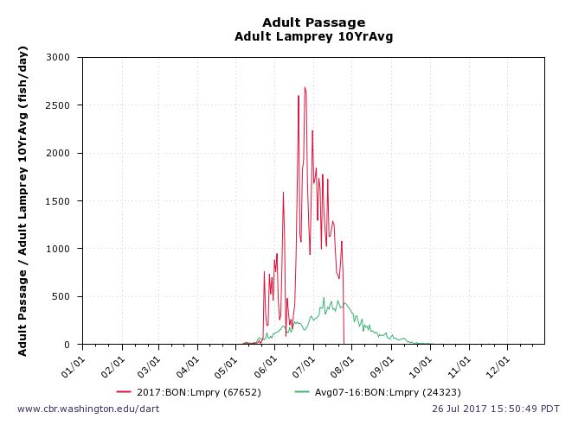

**Figure 3.** Counts for adult Pacific Lamprey at Bonneville Dam. The current 2017 window counts are in red and the 10 year average is (2007 – 2016) shown in green. Data pulled from Dart at www.cbr.washington.edu/dart.

Impacts to out migrating juvenile Pacific Lamprey are anticipated to be unaffected.

Below are tables showing adult salmonid fish passage estimates (by species) for the outage periods.

Table 1. Washington Shore 10 year average for August 14th-19th (2007-2016).

|  |  |  |  |  |  |  |
| --- | --- | --- | --- | --- | --- | --- |
| **Washington Shore 10 Year Average** | | | | | | |
| **Date** | **CHN** | **STT** | **COHO** | **SOC** | **CHUM** | **PINK** |
| **14-Aug** | 772 | 3,579 | 45 | 5 | 0 | 0 |
| **15-Aug** | 790 | 2,952 | 39 | 6 | 0 | 0 |
| **16-Aug** | 767 | 2,535 | 50 | 3 | 0 | 1 |
| **17-Aug** | 969 | 2,349 | 71 | 4 | 0 | 1 |
| **18-Aug** | 1,453 | 2,383 | 121 | 3 | 0 | 1 |
| **19-Aug** | 1,938 | 2,428 | 149 | 6 | 0 | 1 |

**Comments from agencies-**

**Final coordination results-**

**After Action update**

Please email or call with questions or concerns.

Thank you,

Erin

Erin Kovalchuk

NWP Operations Division Fishery Section  
Columbia River Coordination Biologist

Erin.H.Kovalchuk@usace.army.mil

Ricardo Walker

Fish Biologist

NWP Environmental Resources Branch

503-808-4709 (Office)

Ricardo.walker@usace.army.mil